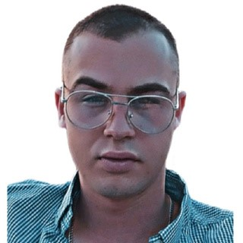

Vukasin Klisura

FRONT-END DEVELOPER

Vukasin is my name, and I am 21

years old. I value communication

and cooperation in a team. I always

aim to get better, and ambition is

one of my attributes. I enjoy

growing and taking on new

challenges. I really think that

success comes from working

together as a team, and I am eager

to participate in initiatives where I

can provide my expertise.

PROFILE

CONTACT ME

EDUCATION

Higher Education Technical

School of Professional Studies in

Novi Sad - VTSNS

2020 -

LANGUAGES

Serbian

English

SKILLS

**Bartender**

→

Casper Bar | 2022 April - 022 December

**Freelance**

→

Making progress on a simple project to design a

user interface. Working on a project component

that entails creating an interface for users.

→

Front-End Coding (JS, HTML, CSS,

Webflow)

→

Basic understanding of using PHP and

MySQL to work with databases.

→

Understanding of MVC architecture and

fundamental knowledge using React and C#.

https://www.linkedin.com/in/vukasin-klisura-183a40226/

vuleklis@gmail.com

+381 65 446 9552

https://github.com/vuleCode

WORK HISTORY

MORE ABOUT ME

In my spare time, I enjoy reading, playing darts, watching documentaries, and taking part in other educational activities. For these reasons, I can claim that art and poetry represent a significant part of my existence.

In addition, I enjoy chilly showers, lengthy evenings, and black coffee.